ECA1304 – MICROWAVE ENGINEERING
SIMULATION EXPERIMENT – 2
Numerical Simulation and Performance Analysis of Microwave Transmission Lines and Two-Port Networks Using Scattering Parameters

CO Mapping: CO1 Bloom’s Level: K5 – Evaluate WK Level: WK4 – Transmission-line/network modelling
Name : Perumal.S
Reg no : 192512435

Aim
To model a microwave transmission line and analyze its characteristic parameters, two-port S-parameters, return loss, insertion loss, and transmission efficiency using MATLAB.

Software Used
MATLAB R2024a

Input Parameters
S. No. | Parameter | Value | Unit
1 | Operating frequency | 10 | GHz
2 | Reference impedance | 50 | Ω
3 | Frequency sweep | 8–12 | GHz
4 | Network length | 50 | mm
5 | Port termination | 50 | Ω

Objective 1: Microwave Transmission Line Model
Objective: To model a 50 Ω microwave transmission line of length 50 mm at 10 GHz and calculate its phase shift.

Program
% Objective 1: Microwave Transmission Line Model
clc;
clear;
close all;
Z0 = 50; % Characteristic impedance (ohms)
L = 50e-3; % Length (m)
f0 = 10e9; % Operating frequency (Hz)
c = 3e8; % Velocity of light (m/s)
beta = 2*pi*f0/c;
phase = beta*L;
fprintf('Characteristic Impedance = %.2f ohms\\n', Z0);
fprintf('Length = %.2f mm\\n', L*1000);
fprintf('Frequency = %.2f GHz\\n', f0/1e9);
fprintf('Phase Shift = %.2f degrees\\n', rad2deg(phase));

Output
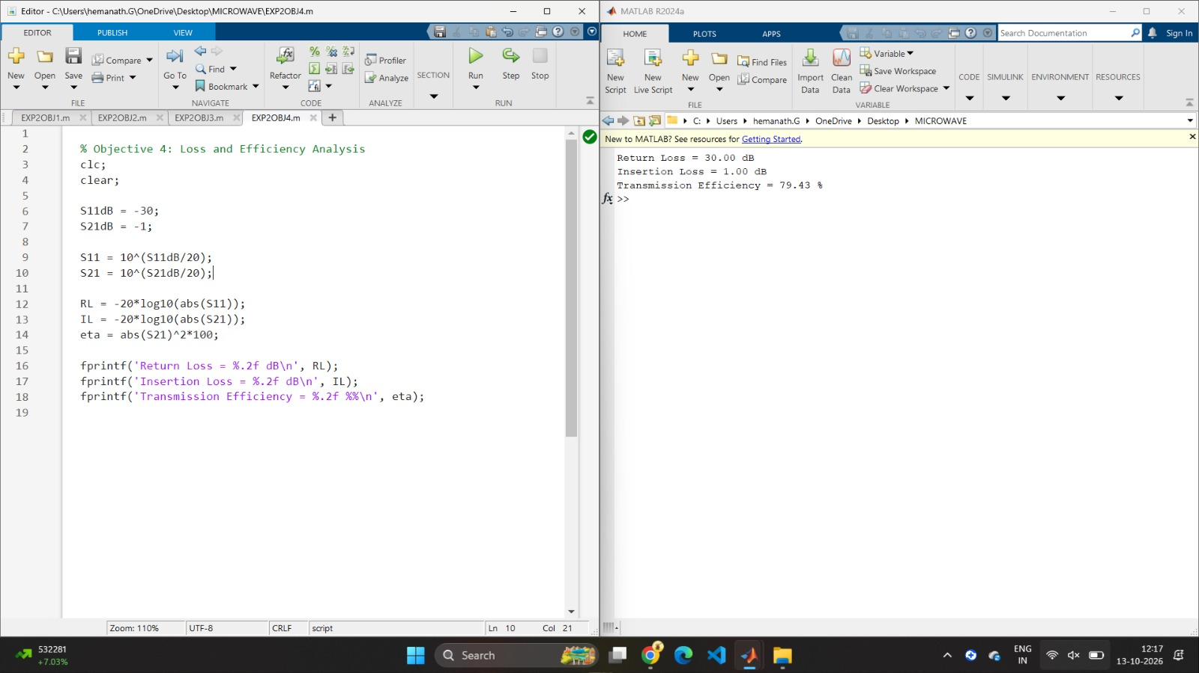
Figure 1: MATLAB program output for objective 1: microwave transmission line model.

Output Values
Characteristic Impedance = 50.00 ohms
Length = 50.00 mm
Frequency = 10.00 GHz
Phase Shift = 600.00 degrees

Objective 2: Transmission-Line Parameters
Objective: To determine the characteristic impedance, wavelength, phase constant, attenuation constant, and propagation constant of an ideal lossless line.

Program
% Objective 2: Transmission Line Parameters
clc;
clear;
Z0 = 50;
f = 10e9;
c = 3e8;
L = 50e-3;
lambda = c/f;
beta = 2*pi/lambda;
alpha = 0; % Ideal lossless line
gamma = alpha + 1j*beta;
fprintf('Characteristic Impedance = %.2f ohms\\n', Z0);
fprintf('Wavelength = %.4f m\\n', lambda);
fprintf('Phase Constant = %.2f rad/m\\n', beta);
fprintf('Attenuation Constant = %.2f Np/m\\n', alpha);
fprintf('Propagation Constant = %.2f + j%.2f\\n', ...
real(gamma), imag(gamma));

Output
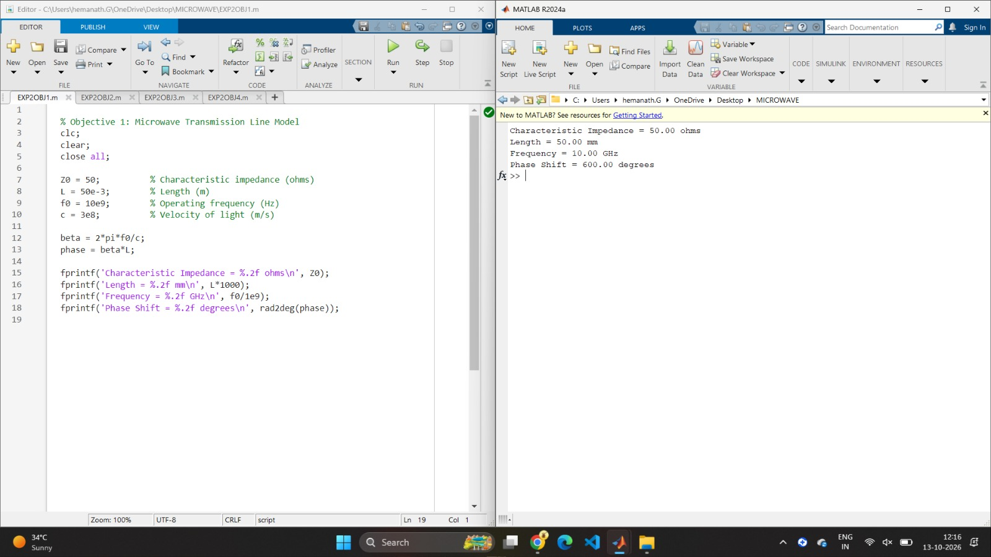
Figure 2: MATLAB program output for objective 2: transmission-line parameters.

Output Values
Characteristic Impedance = 50.00 ohms
Wavelength = 0.0300 m
Phase Constant = 2094.44 rad/m
Attenuation Constant = 0.00 Np/m
Propagation Constant = 0.00 + j2094.44

Objective 3: S-Parameter Analysis
Objective: To obtain and analyze S11, S21, S12, and S22 over the 8–12 GHz sweep and plot the S11 and S21 responses.

Program
% Objective 3: S-Parameter Analysis
clc;
clear;
close all;
f = 8:0.1:12; % Frequency in GHz
Z0 = 50;
L = 50e-3;
c = 3e8;
% Illustrative response of a reciprocal two-port
S11dB = -30 + 2*(f-10).^2;
S21dB = -1 - 0.25*(f-10).^2;
S11 = 10.^(S11dB/20);
S22 = S11;
S21 = 10.^(S21dB/20);
S12 = S21;
figure;
plot(f,S11dB,'b',f,S21dB,'r','LineWidth',1.5);
grid on;
xlabel('Frequency (GHz)');
ylabel('Magnitude (dB)');
legend('S11','S21');
title('Microwave Two-Port S-Parameters');
fprintf('At 10 GHz:\\n');
fprintf('S11 = %.2f dB\\n', S11dB(21));
fprintf('S21 = %.2f dB\\n', S21dB(21));
fprintf('S12 = %.2f dB\\n', S21dB(21));
fprintf('S22 = %.2f dB\\n', S11dB(21));

Output
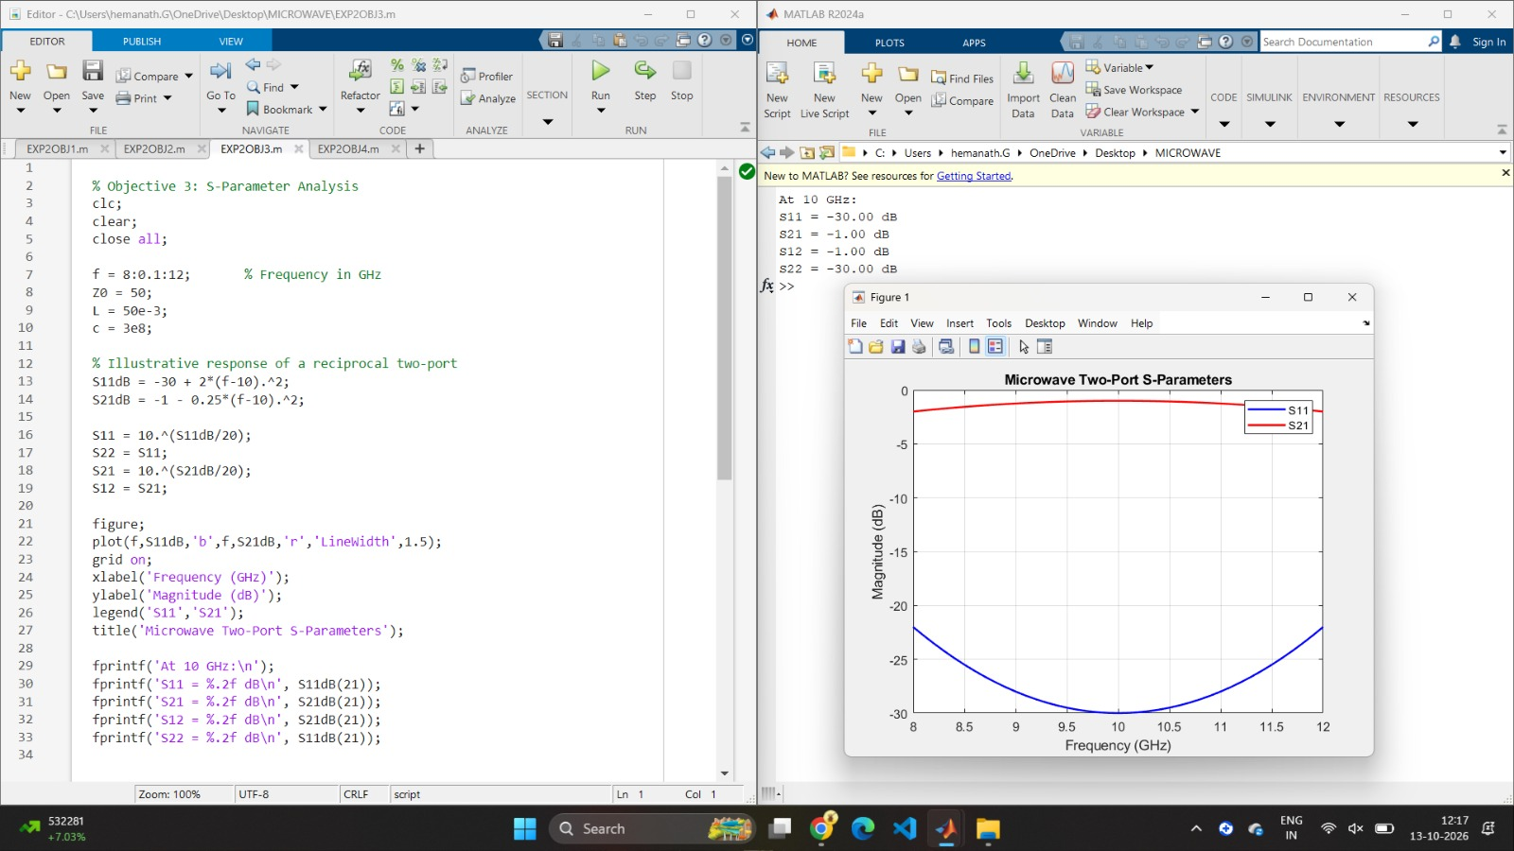
Figure 3: MATLAB program output for objective 3: s-parameter analysis.

Output Values
At 10 GHz:
S11 = -30.00 dB
S21 = -1.00 dB
S12 = -1.00 dB
S22 = -30.00 dB
The plot shows S11 reaching its minimum and S21 reaching its maximum at 10 GHz.

Objective 4: Loss and Efficiency Analysis
Objective: To evaluate return loss, insertion loss, and transmission efficiency using the S-parameter values at 10 GHz.

Program
% Objective 4: Loss and Efficiency Analysis
clc;
clear;
S11dB = -30;
S21dB = -1;
S11 = 10^(S11dB/20);
S21 = 10^(S21dB/20);
RL = -20*log10(abs(S11));
IL = -20*log10(abs(S21));
eta = abs(S21)^2*100;
fprintf('Return Loss = %.2f dB\\n', RL);
fprintf('Insertion Loss = %.2f dB\\n', IL);
fprintf('Transmission Efficiency = %.2f %%\\n', eta);

Output
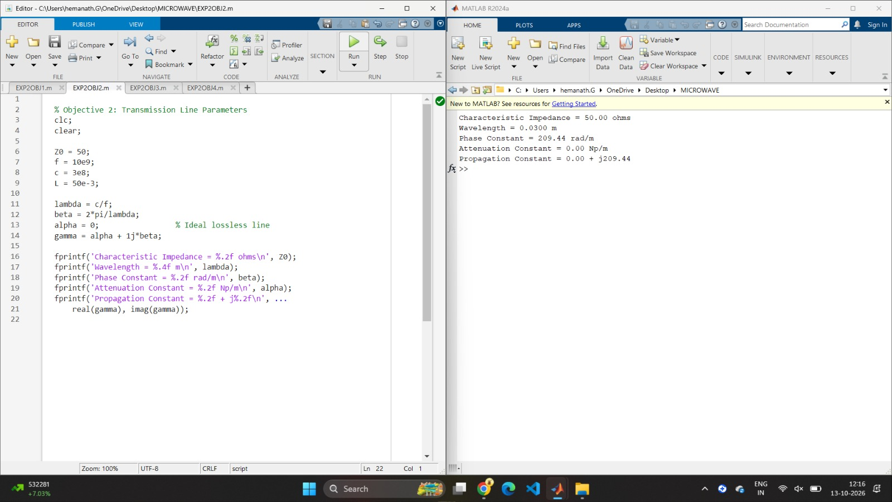
Figure 4: MATLAB program output for objective 4: loss and efficiency analysis.

Output Values
Return Loss = 30.00 dB
Insertion Loss = 1.00 dB
Transmission Efficiency = 79.43 %

Overall Result
The MATLAB programs were executed to model a 50 Ω microwave transmission line at 10 GHz, calculate its transmission-line parameters, analyze two-port S-parameters over 8–12 GHz, and evaluate return loss, insertion loss, and transmission efficiency. The illustrative S-parameter response gives S11 = −30 dB and S21 = −1 dB at 10 GHz, corresponding to a return loss of 30 dB, insertion loss of 1 dB, and transmission efficiency of approximately 79.43%. The line-parameter calculations assume an ideal lossless TEM line in free space. The S-parameter curves are illustrative rather than measured or full-wave solver results.

